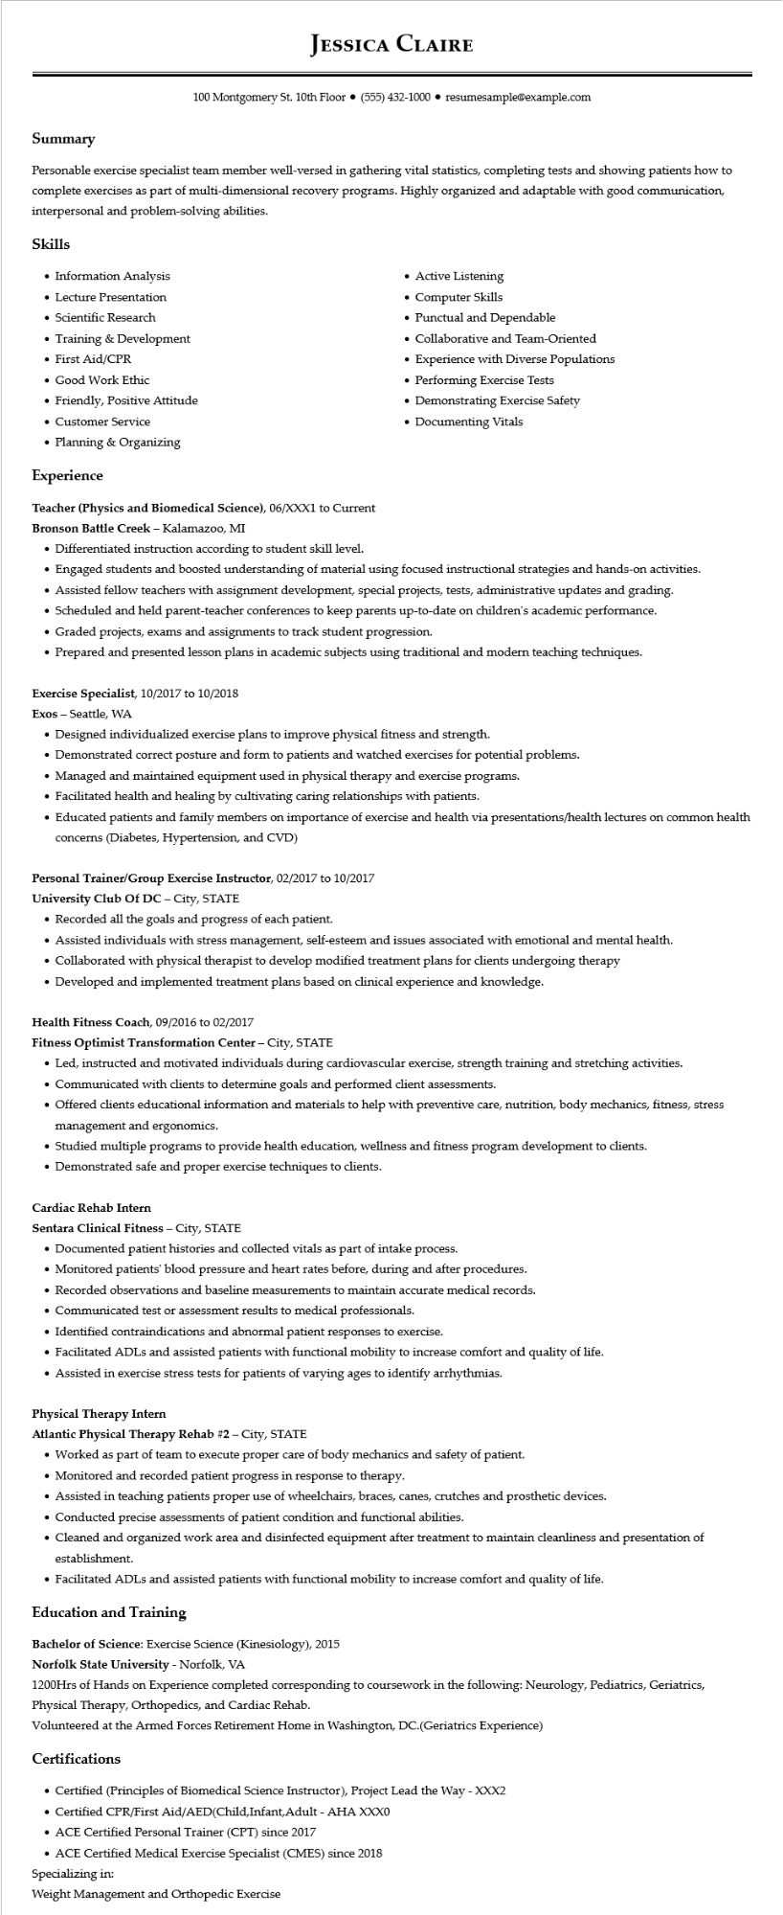
JESSICA CLAIRE
100 Montgomery St. 10th Floor ⚫ (555) 432-1000⚫ resumesample@example.com
Summary
Personable exercise specialist team member well-versed in gathering vital statistics, completing tests and showing patients how to complete exercises as part of multi-dimensional recovery programs. Highly organized and adaptable with good communication, interpersonal and problem-solving abilities.
Skills
• Information Analysis
• Lecture Presentation
• Scientific Research
• Training & Development
• First Aid/CPR
• Good Work Ethic
• Friendly, Positive Attitude
• Customer Service
• Planning & Organizing
Experience
Teacher (Physics and Biomedical Science), 06/XXX1 to Current Bronson Battle Creek - Kalamazoo, MI
• Differentiated instruction according to student skill level.
• Active Listening
• Computer Skills
• Punctual and Dependable
• Collaborative and Team-Oriented
• Experience with Diverse Populations
• Performing Exercise Tests
• Demonstrating Exercise Safety
• Documenting Vitals
• Engaged students and boosted understanding of material using focused instructional strategies and hands-on activities.
• Assisted fellow teachers with assignment development, special projects, tests, administrative updates and grading.
• Scheduled and held parent-teacher conferences to keep parents up-to-date on children's academic performance.
• Graded projects, exams and assignments to track student progression.
• Prepared and presented lesson plans in academic subjects using traditional and modern teaching techniques.
Exercise Specialist, 10/2017 to 10/2018
Exos Seattle, WA
• Designed individualized exercise plans to improve physical fitness and strength.
• Demonstrated correct posture and form to patients and watched exercises for potential problems.
• Managed and maintained equipment used in physical therapy and exercise programs.
• Facilitated health and healing by cultivating caring relationships with patients.
• Educated patients and family members on importance of exercise and health via presentations/health lectures on common health concerns (Diabetes, Hypertension, and CVD)
Personal Trainer/Group Exercise Instructor, 02/2017 to 10/2017
University Club Of DC - City, STATE
• Recorded all the goals and progress of each patient.
• Assisted individuals with stress management, self-esteem and issues associated with emotional and mental health.
• Collaborated with physical therapist to develop modified treatment plans for clients undergoing therapy
• Developed and implemented treatment plans based on clinical experience and knowledge.
Health Fitness Coach, 09/2016 to 02/2017
Fitness Optimist Transformation Center - City, STATE
• Led, instructed and motivated individuals during cardiovascular exercise, strength training and stretching activities.
• Communicated with clients to determine goals and performed client assessments.
• Offered clients educational information and materials to help with preventive care, nutrition, body mechanics, fitness, stress management and ergonomics.
• Studied multiple programs to provide health education, wellness and fitness program development to clients.
• Demonstrated safe and proper exercise techniques to clients.
Cardiac Rehab Intern
Sentara Clinical Fitness - City, STATE
• Documented patient histories and collected vitals as part of intake process.
• Monitored patients' blood pressure and heart rates before, during and after procedures.
• Recorded observations and baseline measurements to maintain accurate medical records.
• Communicated test or assessment results to medical professionals.
• Identified contraindications and abnormal patient responses to exercise.
• Facilitated ADLs and assisted patients with functional mobility to increase comfort and quality of life.
• Assisted in exercise stress tests for patients of varying ages to identify arrhythmias.
Physical Therapy Intern
Atlantic Physical Therapy Rehab #2 - City, STATE
• Worked as part of team to execute proper care of body mechanics and safety of patient.
• Monitored and recorded patient progress in response to therapy.
• Assisted in teaching patients proper use of wheelchairs, braces, canes, crutches and prosthetic devices.
• Conducted precise assessments of patient condition and functional abilities.
• Cleaned and organized work area and disinfected equipment after treatment to maintain cleanliness and presentation of establishment.
• Facilitated ADLs and assisted patients with functional mobility to increase comfort and quality of life.
Education and Training
Bachelor of Science: Exercise Science (Kinesiology), 2015
Norfolk State University - Norfolk, VA
1200Hrs of Hands on Experience completed corresponding to coursework in the following: Neurology, Pediatrics, Geriatrics, Physical Therapy, Orthopedics, and Cardiac Rehab.
Volunteered at the Armed Forces Retirement Home in Washington, DC.(Geriatrics Experience)
Certifications
• Certified (Principles of Biomedical Science Instructor), Project Lead the Way - XXX2
• Certified CPR/First Aid/AED(Child,Infant,Adult - AHA XXX0
• ACE Certified Personal Trainer (CPT) since 2017
• ACE Certified Medical Exercise Specialist (CMES) since 2018
Specializing in:
Weight Management and Orthopedic Exercise

